POWER BI WEEK 4 PROJECT REPORT

Shop Finance – Simple Moving Average Analysis Dashboard

1. Student Details

Name: Keerthana R
Roll No: E25DA024
Department: B.Sc. Data Science and Artificial Intelligence
Tool Used: Microsoft Power BI
Dataset: Shop Finance

2. Objective

The objective of this project is to perform further analysis on the Shop Finance dataset using Microsoft Power BI. The main focus of this week is to calculate and visualize 20-Day and 50-Day Simple Moving Averages (SMA).

The moving averages are used to smooth daily fluctuations and understand the overall trend in stock prices and trading volume over time.

3. Dataset

The Shop Finance dataset contains historical stock market information such as:

- Date
- Open Price
- High Price
- Low Price
- Close Price
- Adjusted Close
- Trading Volume

The dataset was used for performing time-based financial analysis and calculating moving averages.

4. Data Preparation

The dataset was prepared in Power BI before creating the SMA calculations.

The Date column and numerical columns were checked for their appropriate data types. The existing Date Table created for the previous analysis was also used for time-based calculations.

After completing the required preparation, the data was loaded into Power BI for further analysis.

5. Date Table

The Date Table was used to provide a continuous date structure for the moving average calculations.

The Date Table contains fields such as:

- Date
- Year
- Quarter
- Month
- Day

Using the Date Table allows the SMA calculations to be performed consistently across different dates and time periods.

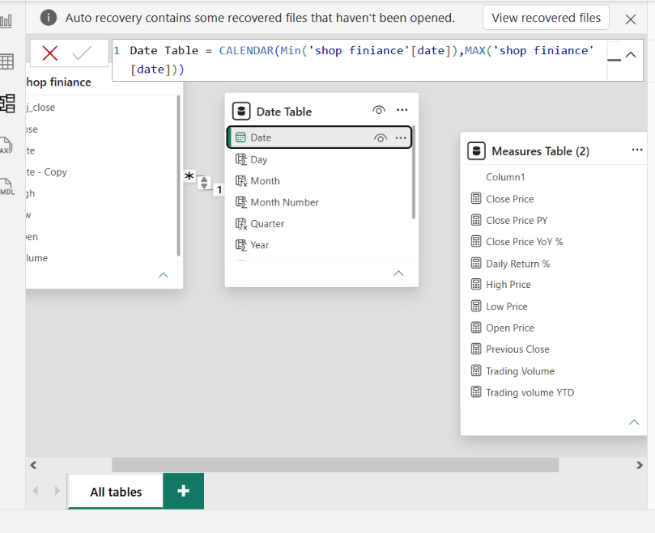
6. Simple Moving Average

A Simple Moving Average (SMA) is a calculation used to find the average value over a specific number of previous periods.

In this project, two moving averages were calculated:

- 20-Day SMA
- 50-Day SMA

The 20-Day SMA represents a shorter-term trend, while the 50-Day SMA provides a broader view of the data over a longer period.

7. Creating 20-Day SMA

A DAX measure was created to calculate the 20-Day Simple Moving Average.

The calculation considers the values from the current date and the previous 19 days to calculate the average for a 20-day period.

The 20-Day SMA helps reduce daily fluctuations and provides a smoother view of the short-term trend. 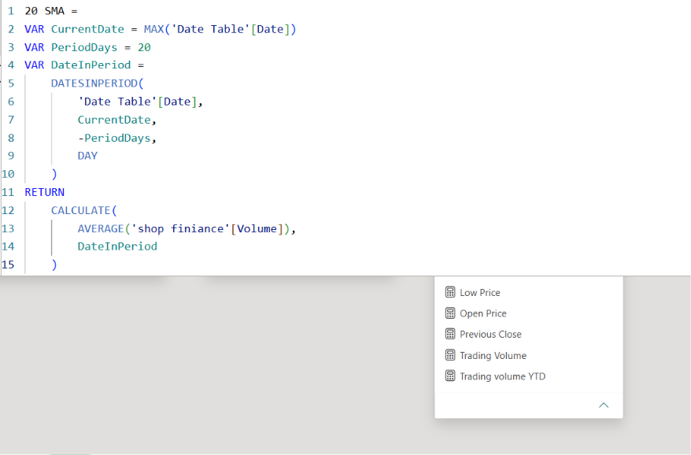

8. Creating 50-Day SMA

A separate DAX measure was created to calculate the 50-Day Simple Moving Average.

The calculation considers a 50-day period and provides a smoother representation of the overall trend compared with the 20-Day SMA.

The 50-Day SMA can be used to observe relatively longer-term movements in the selected financial data.

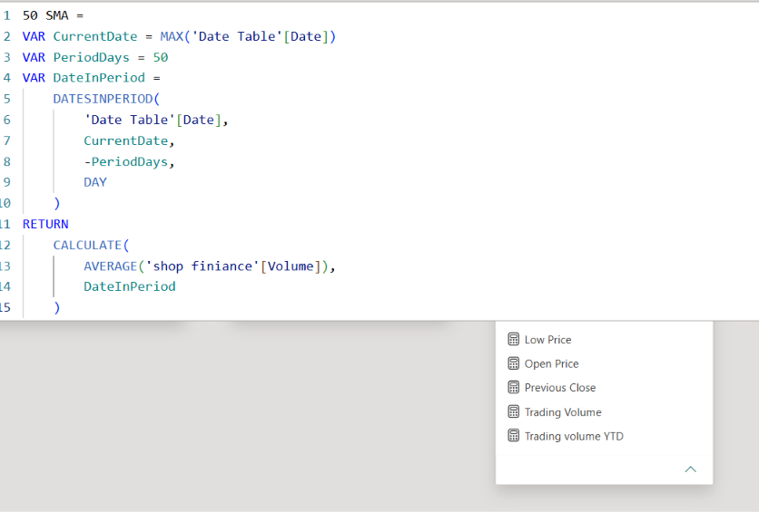

9. Volume 20-Day SMA

A separate measure was also created to calculate the 20-Day Simple Moving Average of Trading Volume.

This measure helps smooth daily changes in trading volume and provides a clearer view of the average trading activity over a 20-day period.

10. Dashboard Visualizations

10.1 20-Day SMA

A visual was created using the 20-Day SMA measure to display the moving average over time.

X-axis: Date
Y-axis: 20-Day SMA

The visual helps observe short-term changes and trends in the selected data.

---

10.2 50-Day SMA

A visual was created using the 50-Day SMA measure.

X-axis: Date
Y-axis: 50-Day SMA

This visual provides a smoother view of the longer-term trend and can be compared with the 20-Day SMA.

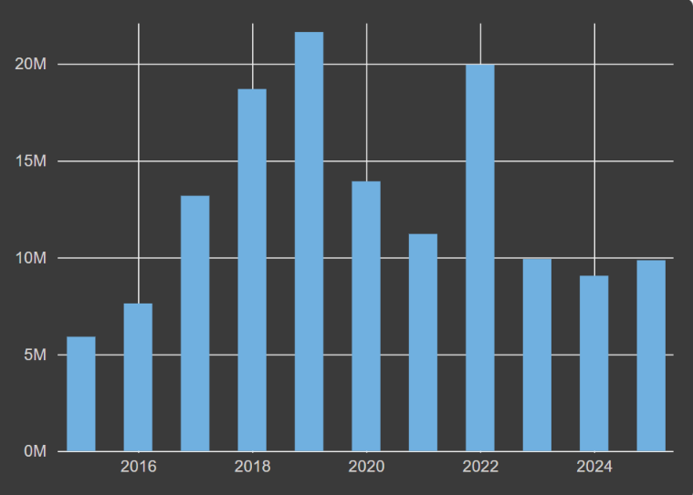

---

10.3 Volume 20-Day SMA

A visual was created using the Volume 20-Day SMA measure.

X-axis: Date
Y-axis: Volume 20-Day SMA

This chart shows the average trading volume over a 20-day period and helps identify changes in trading activity.
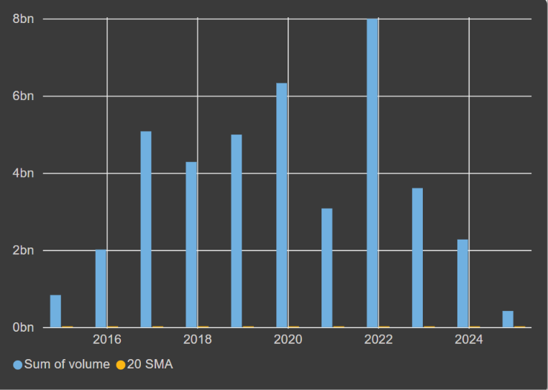

---

11. SMA Comparison

The 20-Day and 50-Day SMA were used together to understand different time periods of the financial data.

The 20-Day SMA reacts more closely to recent changes because it uses a shorter period. The 50-Day SMA changes more gradually because it considers a longer period.

Comparing both moving averages provides a clearer view of short-term and longer-term movements.
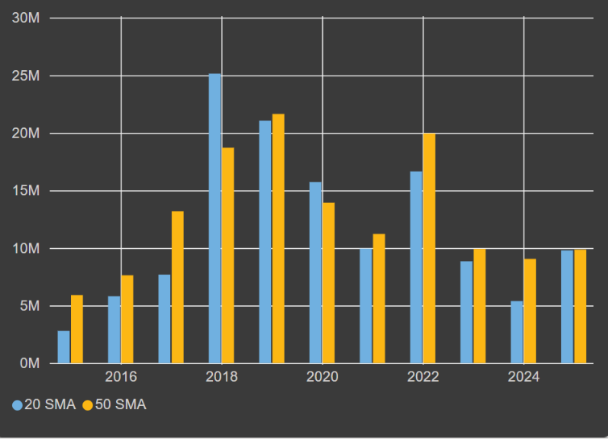

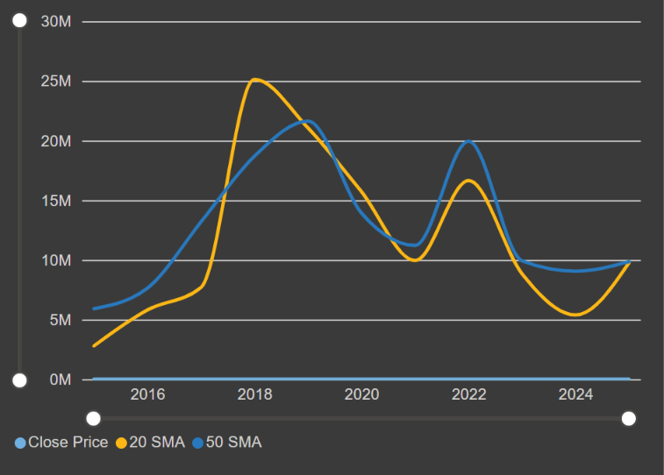

---

12. Slicer and Dashboard Interactivity

A date-based slicer was used to make the dashboard interactive.

The user can select a particular time period and view the corresponding SMA values and charts.

The existing date hierarchy and drill-down functionality can also be used to explore the data at different levels such as:

Year → Quarter → Month → Date
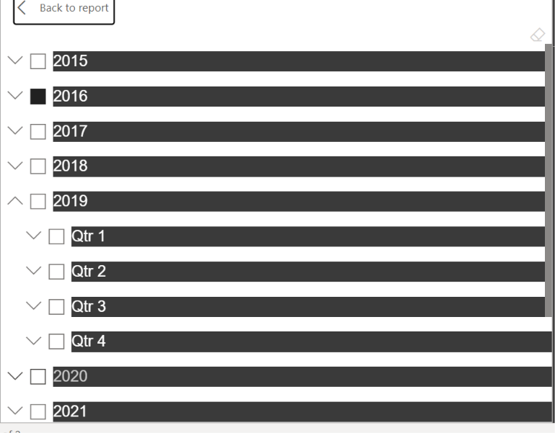

13. Key Observations

The SMA analysis provides a smoother representation of the financial data compared with daily values.

- The 20-Day SMA helps observe relatively short-term movements.
- The 50-Day SMA provides a broader view of the trend.
- Moving averages reduce the effect of individual daily fluctuations.
- The Volume 20-Day SMA helps understand average trading activity.
- Comparing different SMA periods makes trend analysis easier.
- Interactive date filtering allows the analysis to be performed for selected periods.

---

14. Conclusion

The Week 4 Power BI project focuses on applying Simple Moving Average analysis to the Shop Finance dataset. Using DAX, 20-Day and 50-Day moving averages were calculated to provide a smoother representation of the financial data.

The Volume 20-Day SMA was also created to analyse average trading activity over a 20-day period. These measures were then used in Power BI visuals along with date-based filtering and dashboard interactivity.

Overall, this project provided practical experience in creating DAX-based time-series calculations and using moving averages to analyse financial data in Power BI.

